**Algorithms & Data Structures Hands_On**

**Exercise 2: E-commerce Platform Search Function**

**Scenario:**

You are working on the search functionality of an e-commerce platform. The search needs to be optimized for fast performance

PROGRAM: 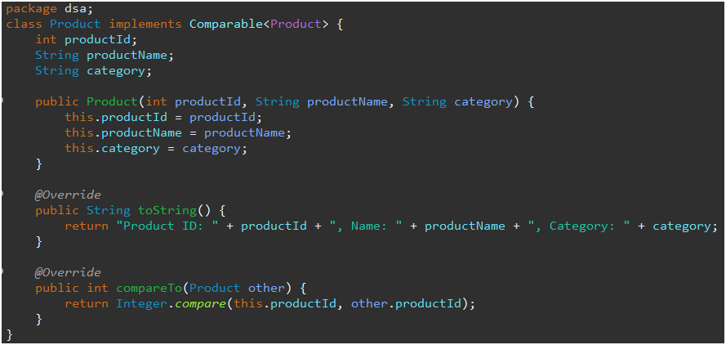

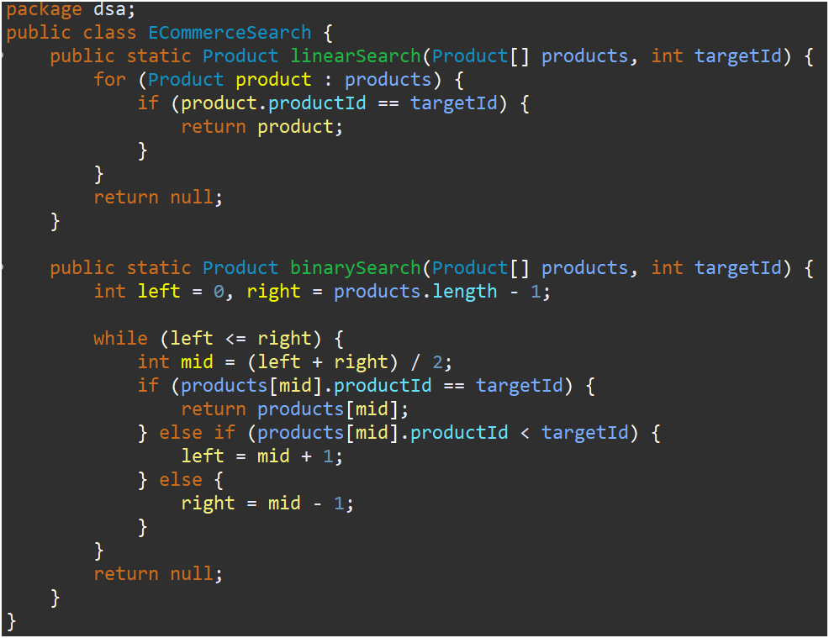

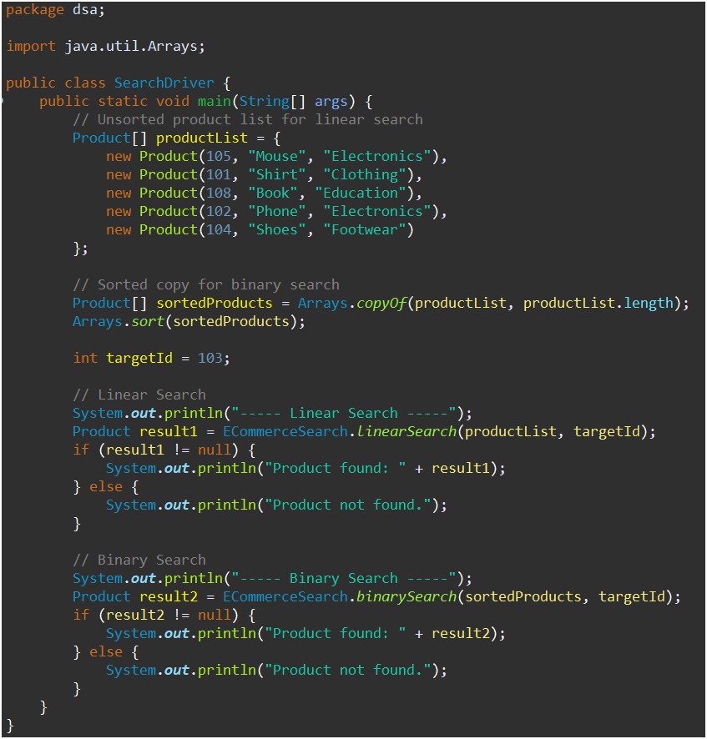

Output:

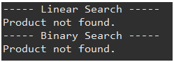

**Exercise 7: Financial Forecasting**

**Scenario:**

You are developing a financial forecasting tool that predicts future values based on past data.

PROGRAM:

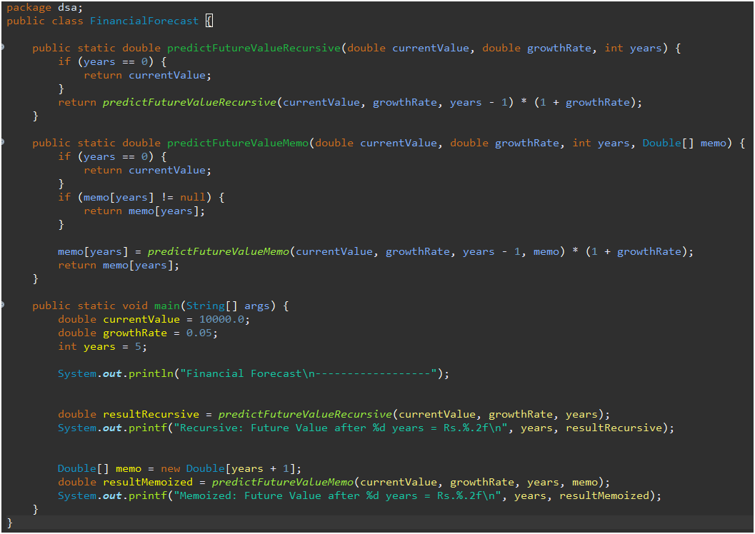

Output:

